Hasil Pengetesan Test QA - Jubelio

1. Test QA-Jubelio -- Membuka Link Test Jubelio dan Login (failed)

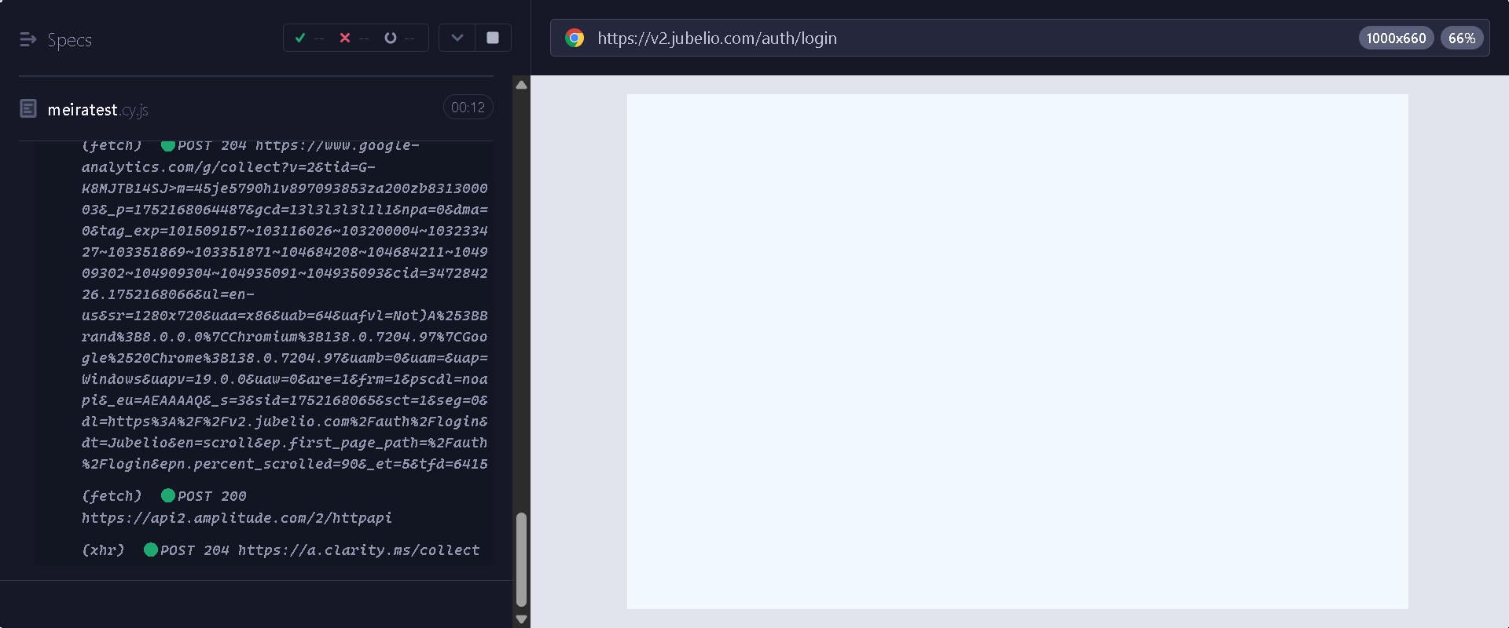

1. should successfully search for an order (Pesanan) (failed)

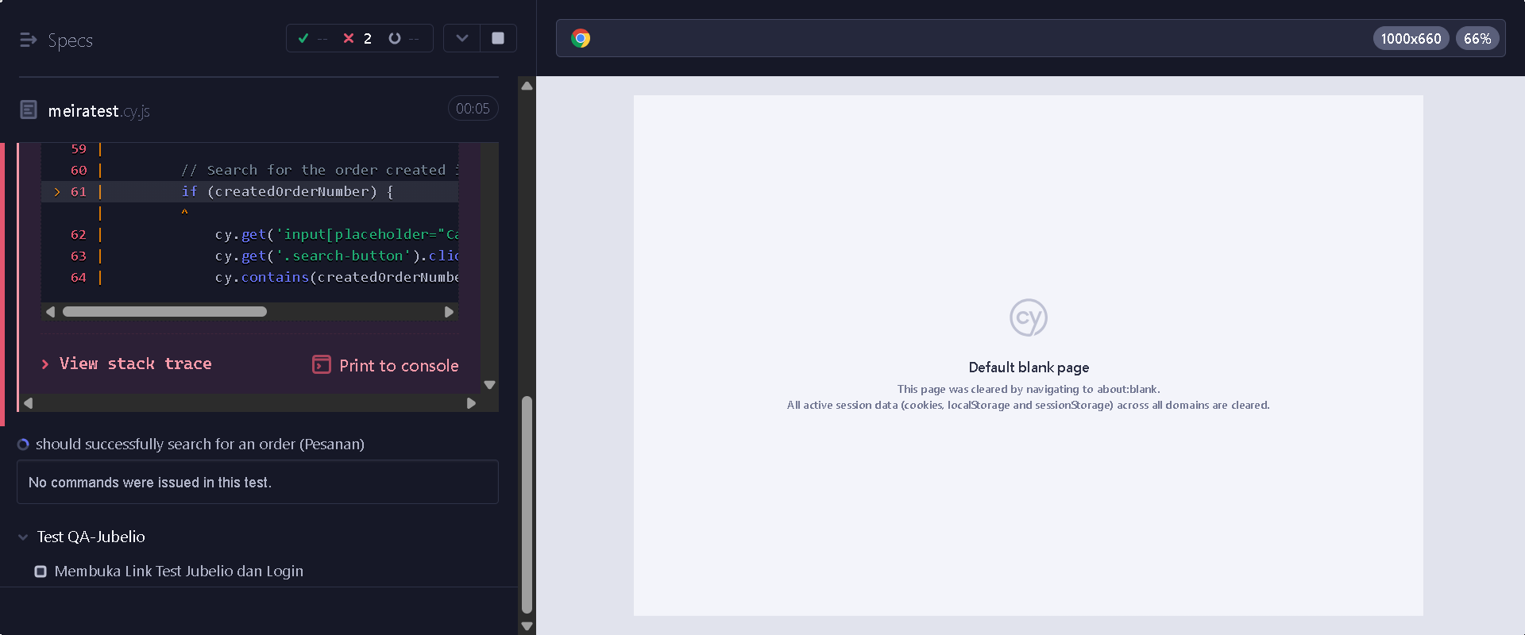

1. should successfully edit an existing order (Pesanan) (failed)

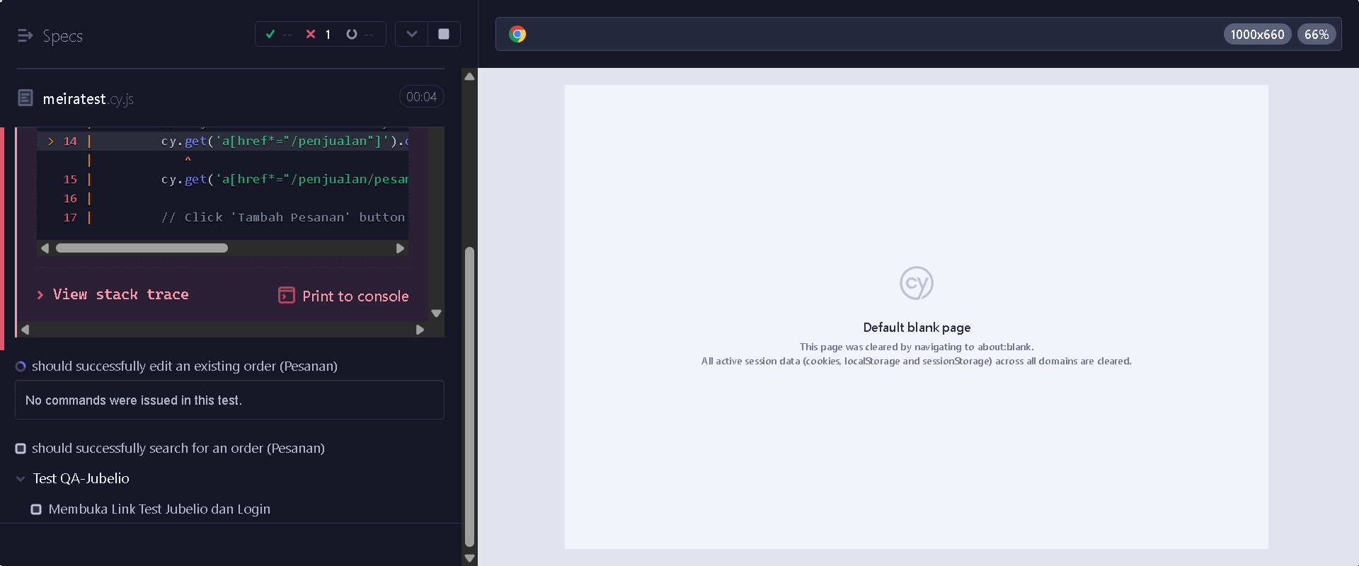

1. should successfully create a new order (Pesanan) (failed)

